Friends of The Crown Inn Dilwyn
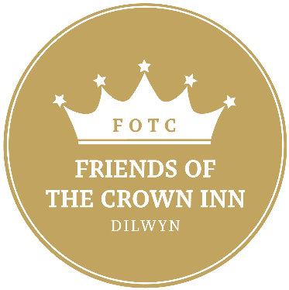
The Friends of the Crown was formed as an independent group focused on fundraising to help with both maintenance and development costs of The Crown Inn Site, given its significance as a village asset.
The Friends of the Crown does not interfere with or fund the day to day running of the pub business.

The Friends was formed in 2013 and since then we have organised a number of events for the community: gourmet nights at the Crown with guest chefs; music nights in the village hall; quiz nights; beetle drives & coffee mornings in the Crown, to name a few.
In 2020 we launched our website which can be accessed by clicking here.
The main priority of the website will be to inform you and members of the community. Here we will host the latest news from ideas, new projects, monthly updates, fundraising events and planning, committee meetings and the chance to have your say.
It will also have the ability to receive online donations and in the Summer 2020 it will be home to our Friendship scheme. The top priority of the scheme is to raise funding to carry out the much-needed work to preserve the site. Additionally, members of the scheme will be encouraged to get involved as much as they want. There are plenty of opportunities to support the community from assisting in fundraising events, volunteering and the donation of materials for projects. Find out more and how to become a friend by clicking here.

