DILWYNS LISTED BUILDINGS

There are three types of listed status for buildings in England and Wales: Grade I: buildings of exceptional interest. Grade II*: particularly important buildings of more than special interest. Grade II: buildings that are of special interest. Every effort will be made to preserve these buildings for future generations.
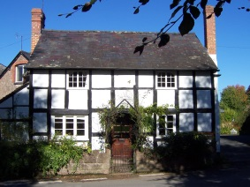
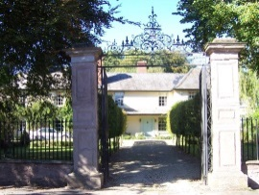
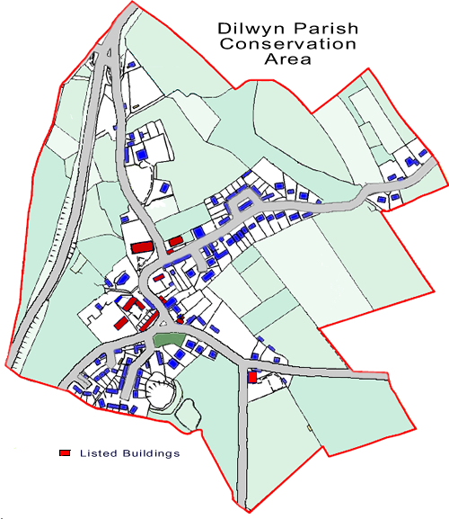

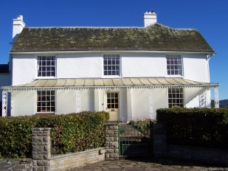
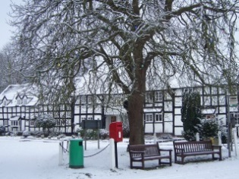

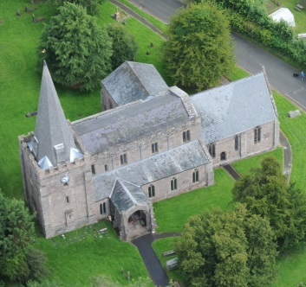

LIST OF BUILDINGS

CASTLE MOUND
Schedule Ancient Monument:

ST MARY’S CHURCH
Heritage Category: Grade: I

LITTLE DILWYN FARM,
Heritage Category: Grade: II

ST MARYS C of E SCHOOL
Heritage Category: Grade: II

LITTLE DILWYN FARMHOUSE
Heritage Category: Grade: II

RAILINGS AND RETAINING WALL TO WEST OF TOWNSEND HOUSE
Heritage Category: Grade: II

SCHOOL HOUSE
Heritage Category: Grade: II

TOWNSEND HOUSE
Heritage Category: Grade: II

CHURCH COTTAGE
Heritage Category: Grade: II

THE OLD FORGE
Heritage Category: Grade: II

GARDEN WALL, RAILINGS, GATES AND GATE PIERS TO SOUTH EAST OF THE GREAT HOUSE
Heritage Category: Grade: II

THE GREAT HOUSE
Heritage Category: Grade: II

Heritage Category: Grade: II

LYNWOOD DOVE COTTAGES
Heritage Category: Grade: II

WREN COTTAGES
Heritage Category: Grade: II

YEW TREE COTTAGES
Heritage Category: Grade: II
SWANSTONE COURT & BUILDINGS
Heritage Category: Grade: II*
LUNTLEY COURT
Heritage Category: Grade: II*
LUNTLEY COURT GRANARY, BARN STABLES & DOVECOTE
Heritage Category: Grade: II
BIDNEY FARM HOUSE & DOVECOTE
Heritage Category: Grade: II
LOWER HURST DOVECOTE
Heritage Category: Grade: II
HENWOOD , HOP KILN, STABLES & OUT BUILDINGS
Heritage Category: Grade: II
LOWER CHADNOR
Heritage Category: Grade: II
PITCH FARMHOUSE & COTTAGE
Heritage Category: Grade: II
THE BROWNS
Heritage Category: Grade: II
STOCKING HOUSE
Heritage Category: Grade: II
UPPER DEWELL
Heritage Category: Grade: II
DUNWOOD FARMHOUSE & GRANARY
Heritage Category: Grade: II
HILL TOP EAST BARN
Heritage Category: Grade: II

