Housing Needs Assessment
Dilwyn, Herefordshire

March 2017
Final Report

Contents

Glossary of terms used in text 5
Chapter 1: Executive summary 6
Introduction 6
PPG-Based Assessment 6
Summary of Methodology 6
Gathering and Using a Range of Data 7
Focus On Demand Rather Than Supply 8
Quantity of Housing Needed 8
Recommendations for next steps 13
Chapter 2: Context 15
Local context 15
Local Planning Context 16
Chapter 3: Approach 16
Research Questions 16
Quantity 17
Study Objectives 17
Chapter 4: Relevant Data 17
Planning Context 17
Tenure of housing 18
Current Stock 18
Recent supply 19
Age Structure 21
Household composition 22
Affordability 24
Intermediate Housing 26
Proportions of affordable housing 27
Type and Size 29
The needs of older people 33
Quantity 34
Chapter 5: Market Signals 36
Housing Transactions 37
Rate of development 38
Overcrowding 38
Employment trends 38
Chapter 6: Conclusions 40
Recommendations for next steps 44

Limitations

AECOM Infrastructure & Environment UK Limited (“AECOM”) has prepared this Report for the sole use of Dilwyn Parish Council (“Client”) in accordance with the Agreement under which our services were performed. No other warranty, expressed or implied, is made as to the professional advice included in this Report or any other services provided by AECOM.
Where the conclusions and recommendations contained in this Report are based upon information provided by others it is upon the assumption that all relevant information has been provided by those parties from whom it has been requested and that such information is accurate. Information obtained by AECOM has not been independently verified by AECOM, unless otherwise stated in the Report.
The methodology adopted and the sources of information used by AECOM in providing its services are outlined in this Report. The work described in this Report was undertaken in the period March – April 2017 and is based on the conditions encountered and the information available during the said period of time. The scope of this Report and the services are accordingly factually limited by these circumstances.
Where assessments of works or costs identified in this Report are made, such assessments are based upon the information available at the time and where appropriate are subject to further investigations or information which may become available.
AECOM disclaim any undertaking or obligation to advise any person of any change in any matter affecting the Report, which may come or be brought to AECOM’s attention after the date of the Report.
Certain statements made in the Report that are not historical facts may constitute estimates, projections or other forward-looking statements and even though they are based on reasonable assumptions as of the date of the Report, such forward-looking statements by their nature involve risks and uncertainties that could cause actual results to differ materially from the results predicted. AECOM specifically does not guarantee or warrant any estimate or projections contained in this Report.
Where field investigations are carried out, these have been restricted to a level of detail required to meet the stated objectives of the services. The results of any measurements taken may vary spatially or with time and further confirmatory measurements should be made after any significant delay in issuing this Report.
Copyright
© This Report is the copyright of AECOM Infrastructure & Environment UK Limited. Any unauthorised reproduction or usage by any person other than the addressee is strictly prohibited.

Project Role | Name | Position | Actions Summary | Signature | Date
Researcher(s) | Thomas Corbin | Graduate Planner | Data gathering and drafting
Project Manager | Ivan Tennant | Principal Planner | Report drafting and review
Director/QA | Jesse Honey | Principal Planner | Technical Review
Qualifying Body | Deborah Bruton | Dilwyn Parish Council
Project Coordinator

Glossary of terms used in text

AH Affordable Housing (NPPF definition)
AMH Affordable Market Housing
COH The County of Herefordshire
DCLG Department for Communities and Local Government
HLP Herefordshire Local Plan
HNA Housing Needs Assessment
HLHMA Herefordshire Local Housing Market Assessment
LPA Local Planning Authority
LHRS Local Housing Requirements Study Update (2011, 2012 and 2014)
NDP Neighbourhood Development Plan
NPPF National Planning Policy Framework
MH Market Housing
OAN Objectively Assessed Need
ONS Office for National Statistics
PPG Planning Practice Guidance
PRS Private Rented Sector
SHLAA Strategic Housing Land Availability Assessment
SHMA Strategic Housing Market Assessment

Chapter 1: Executive summary

Introduction
- The 2011 Localism Act introduced neighbourhood planning, allowing parishes, town councils or neighbourhood forums across England to develop and adopt legally binding development plans for their neighbourhood area.
- As more and more parishes, towns and forums seek to address housing growth, including tenure and type of new housing, it has become evident that developing policies need to be underpinned by robust, objectively assessed housing data.
- In the words of the national Planning Practice Guidance (PPG), establishing future need for housing is not an exact science, and no single approach will provide a definitive answer. The process involves making balanced judgments, as well as gathering numbers and facts. At a neighbourhood planning level, one important consideration is determining the extent to which the neighbourhood diverges from the local authority average, reflecting the fact that a single town or neighbourhood almost never constitutes a housing market on its own and must therefore be assessed in its wider context.
- The guidance quoted above on housing needs assessment is primarily aimed at local planning authorities preparing Strategic Housing Market Assessments (SHMAs), which are used to determine housing need at a local authority level. However, it helpfully states that those preparing neighbourhood plans can use the guidance to identify specific local needs that may be relevant to a neighbourhood, but that any assessment at such a local level should be proportionate.
- Our brief was to advise on data at this more local level to help Dilwyn Parish Council understand, among other matters, the type, tenure and quantity of housing needed to inform neighbourhood plan policies.

PPG-Based Assessment
- This objective and independent housing needs advice note follows the PPG approach where relevant. This ensures our findings are appropriately evidenced. The PPG advises that assessment of development needs should be thorough but proportionate and does not require planners to consider purely hypothetical future scenarios, only future scenarios that could be reasonably expected to occur.

Summary of Methodology
- Housing Needs Assessment at neighbourhood plan level can be focused either on quantity of housing needed, type of housing need, or both. In most cases, there is a need to focus on quantity where the housing target for the settlement being assessed is unclear, for example where the local authority has not set a specific target for the settlement, or where there is no local plan in place.
- In the case of Dilwyn, the current adopted Development Plan, the Herefordshire Local Plan (HLP) has allocated through one major site and a range of smaller development opportunities, 42 dwellings in the parish of Dilwyn over the plan period 2011-31. As a plan that post-dates the National Planning Policy Framework, this should be used as a guiding authority on housing numbers. The Herefordshire Local Housing Market Assessment 2012 (HLHMA) in conjunction with Local Housing Requirements Studies (LHRS) 2011, 2012 and 2014, provide the evidence base for the housing policy at the LPA level. The LHRS 2014 identifies an Objectively Assessed Need for between 15,400 and 16,200 homes in Herefordshire over the 2011-31 plan period.
- Notwithstanding this clarity as to the housing numbers at the LPA level, the Parish Council is interested in generating its own target as it realises 42 dwellings may be insufficient to meet community need in the coming years. The core purpose of this study is therefore to consider both quantity of housing needed, in light of the recently commissioned SHMA, identifying a revised target for housing numbers for Dilwyn, as well as type, in accordance with the wishes of the Parish Council.
- We are mindful that the NDP cannot seek a lower housing target than the number specified in the Local Plan. This is because neighbourhood plans need to pass a number of Basic Conditions to be ‘made’ by the LPA. One of these, Basic Condition E, requires the Neighbourhood Plan to be in ‘general conformity with the strategic policies’ of the Local Plan, in this case the HLP. The Government’s Planning Practice Guidance indicates that the level of housing development is likely to count as a strategic policy.
- In terms of the types of housing needed, there is generally more flexibility on what neighbourhood plans can cover. In order to understand the types of housing needed in Dilwyn Parish, we have gathered a wide range of local evidence and summarised it into policy recommendations designed to inform decisions on housing quantity and characteristics.
- The planning period of neighbourhood plans, where possible, should be aligned with the relevant local plan. This is the case with Dilwyn, and the NDP sets a plan period of 2011-31.

Gathering and Using a Range of Data
- The PPG states that:
‘no single source of information on needs will be comprehensive in identifying the appropriate assessment area; careful consideration should be given to the appropriateness of each source of information and how they relate to one another. For example, for housing, where there are issues of affordability or low demand, house price or rental level analyses will be particularly important in identifying the assessment area. Where there are relatively high or volatile rates of household movement, migration data will be particularly important. Plan makers will need to consider the usefulness of each source of information and approach for their purposes’.
- It continues: ‘Plan makers should avoid expending significant resources on primary research (information that is collected through surveys, focus groups or interviews etc. and analysed to produce a new set of findings) as this will in many cases be a disproportionate way of establishing an evidence base. They should instead look to rely predominantly on secondary data (e.g. Census, national surveys) to inform their assessment which are identified within the guidance’.
- Compared with the 2001 Census, the 2011 Census gathered data in a number of new categories and across a range of geographies that are highly relevant to planning at the neighbourhood level and helpful if a PPG-based approach is being used.
- Like much of the data forming the housing policy evidence base, the Census information is quantitative. However, at a local level, qualitative and anecdotal data, if used judiciously, also has an important role to play, to a perhaps greater extent than at local authority level. We have gathered data from as wide a range of sources as practicable in order to ensure robustness of conclusions and recommendations arising from the analysis of that data. Our conversation with local estate agents, Cobb Amos, Brightwells and Russell Baldwin & Bright, helped ensure our conclusions were informed by a qualitative, local perspective.

Focus On Demand Rather Than Supply
- Our approach is to provide advice on the housing required based on need and/or demand rather than supply. This is in line with the PPG, which states that ‘the assessment of development needs should be an objective assessment of need based on facts and unbiased evidence. Plan makers should not apply constraints to the overall assessment of need, such as limitations imposed by the supply of land for new development, historic under performance, viability, infrastructure or environmental constraints.’
- For this reason, we advise that the conclusions of this report should be assessed against supply-side considerations (including, for example, factors such as transport infrastructure, landscape constraints, flood risk and so on) as a separate and follow-on study.

Quantity of Housing Needed
- Our assessment of a wide range of data sources identified four separate projections of dwelling numbers for Dilwyn between 2011 and 2031 based on:
- A figure derived from the Adopted 2015 Hereford Core Strategy and Hereford Local Housing Market Assessment, giving a total of 44 dwellings;

- A figure derived from the Objectively Assessed Need (OAN) for housing set out in the Local Housing Requirements Study Update - September 2014, giving 61 dwellings;
- DCLG Household Projection of 51 new households in the parish translates into a need for 56 dwellings;
- A figure based on the rate of completions between 2011 and 2016 suggests a target of 6 dwellings. None were completed only two replacement houses
- A further assessment applied to the four projections set out above indicates that the demography of the plan area and the performance of the housing market are likely to impact these projections. We have applied our professional judgment on the scales of increase and decrease associated with each factor on a scale from one to three, where one arrow indicates ‘some impact’, two arrows ‘stronger impact’ and three arrows indicates an even stronger impact. Factors are in alphabetical but no other order.

Table 1: Summary of factors specific to Dilwyn with a potential impact on neighbourhood plan housing
Factor | Source(s) (detailed in Chapter 4) | Possible impact on future housing need | Rationale for judgement
Demographic change | Census, LHRSU (2012) | ↑ | Changes in age structure over the plan period is likely to see a significant growth in the proportion and numbers of people over the age of 75. The area currently has a relatively large number of older people occupying a disproportionately high amount of habitable rooms and therefore some filtering or specialist housing may produce a more effective distribution of the existing housing stock. As a result, an assessment of one up arrow has been made as there is deemed to be an need for an increase in provision of housing suited to ‘downsizing.’
Employment trends | Core Strategy 2015, Rural Settlements Hierarchy Paper 2010. | ↓↓ | Although there are examples of employment growth within the typical commuting distance of the residents of Dilwyn parish, these are unlikely to stimulate additional need for housing in the area due to their vicinity to Leominster and Hereford which are much more densely populated settlements.  One potential impact on the economic viability of the local area, however, is the growing inactivity of the residents caused by an ageing population. As a result, an assessment of two down arrows has been made due to the lack of projected employment growth in the Neighbourhood Plan Area compared with the wider county.
Housing Transactions | Local Housing Market Assessment 2012 update, Local Housing Requirements Study Update, DCLG Live Tables, Rural housing Background Paper March 2013, Local Agent survey | ↑ | The housing market in Dilwyn has been shown to be relatively strong, growing in the last ten years and with higher property prices than neighbouring areas.  The housing stock of the area, typified by detached and semi-detached dwellings and a lack of smaller 2/3 bedroom houses or flats is also joined by a low projected development rate. As a result of this inelasticity in supply any increase in demand will manifest itself as an increase in property prices in the Parish.  Furthermore, there are currently very few opportunities for rent in Dilwyn. As a result, high house prices are likely to increase the need for more affordable or subsidised forms of housing.  Overall, an assessment of one up arrow has been made due to the presence of relatively higher and increasing house prices. This assessment was not higher because these house prices are deemed to be inflated by a significant lack of supply in the Neighbourhood Plan Area.
Overcrowding | Census | ↓↓ | There is relatively little evidence of the overcrowding which typifies inadequate supply. Indeed within the study area, typified by large and non-intensively used housing stock, there is capacity for future need to be accommodated.
Rate of development | Census, Rural Housing Background Paper March 2013, Planning portal data, LA response, Land Registry data. | ↑↑↑ | There have been no completions in the last 6 years, with very few outstanding permissions despite relatively high house prices.  An assessment of three up arrows has therefore been deemed appropriate due to this low level of provision, especially in a context of anticipated increasing need across the Leominster HMA. As a result, overall housing need, a combination of past, present and future demand, is likely to be exacerbated by an unresponsive housing market.

Table 2: Summary of local factors specific to Dilwyn with a potential impact on neighbourhood plan housing characteristics
Factor | Source(s) (see Chapter 4) | Possible impact on housing needed | Conclusion
Affordable Housing | Census, HLHMA | Assertive approach to securing high levels of AH  Development of intermediate housing as a type of AH | There is a very small quantity of social housing, which means private rented accommodation shoulders the bulk of the AH burden.  The result of viability analysis shows different viability levels between urban and rural areas within the LHMA; this should encourage an assertive attitude on the part of the parish council in seeking AH as part of development projects, as well as other initiatives, such as AH exception sites  Given the development of intermediate housing as a type of AH, for example the entry of discounted market housing for rent and purchase into the lexicon of ‘affordable housing,’ these types should form a substantial part of AH provision.  Within rural areas of the LHMA, evidence supports provision of AH in the following ratios: intermediate housing, 32%, affordable rent 15% and social rent 53%.
Demand/need for smaller dwellings | Census, Local Agents Survey, HLHMA. | Smaller homes needed to facilitate down-sizing  1, 2 and 3 bed homes should be priority for families and first-time buyers. | There is a preponderance of large homes, creating a 'top heavy' profile in the current housing stock; this, and other evidence, suggests an under-supply of smaller homes. Local agents report both high demand for three bed properties and an under-supply of these sizes of homes.  Within rural parts of the LHMA there is strong demand for small homes, but not flats, suggesting a mixed typology of dwellings would be approporate in future development, offering one, two and three bedroom homes with a very small number of larger family dwellings.
Demographic Change | Census, LHRSU (2012) | Very substantial increase in older residents is forecast over the plan period | While the population of the parish is too small to warrant specialist housing for the elderly, policy that supports general housing suited to their needs is appropriate
Dwelling size | Census, HLHMA. | No further development of larger homes to rebalance stock in favour of smaller dwellings to address mis-alignment issues. | The preponderance of larger homes in the area suggests that policy should not seek the delivery of homes of four or more bedrooms.  This is supported by demand data which suggests that, while there is strong demand for homes of all scales at county level, within the rural parts of the LHMA there is substantially less demand for AH of four bedrooms and above.  As set out above, there is negligable demand for flats in the plan area; development should therefore offer 1,2 and 3 bed houses.
Family-sized housing | HLHMA, Local Agent Survey | New housing should concentrate on housing families can both use and afford. | Given only a minority of people can afford family housing in the plan area, it is imperative future development supplies housing suited to a family’s needs, but of a type and size they can afford.  The ratio of dwellings sold to people outside the area supports the idea of a local needs policy applied to new AH.
Housing for independent living for older people | Census, HLHMA | Life-time homes policies should be considered | The age structure, how it has changed over time, and the composition of households, suggest a need for ‘life-time homes’ style development. This will help ensure there is adequate housing stock for people to downsize into, combined with a wide range of accommodation suited to family use.
Specialist housing | Census | Not suitable location for provision of specialist housing | The population size within the plan area does not support the delivery of specialist housing beyond general housing suited to the needs of the older resident. Within the LHMA, Leominster is the most appropriate location for such housing.
Tenure of housing |  | More households likely to fall into need as a result of increasing house prices  PRS should be encouraged given the role it plays in providing AH and allowing people to remain in the area. | House price increases are likely to have outstripped real wage increases, placing greater pressure on people's ability to afford housing.  The widespread take-up of PRS suggests a latent demand for discounted market housing and shared ownership products. New development could include Build-to-Rent (BTR); this is housing delivered by specialist developers designed to be occupied specifically by renters, and covenanted for that purpose for a number of years. This would be a means of maintaining the flow of PRS housing, a portion of which may be ‘discounted market rent’. Following the Housing White Paper, this is likely to be included in the definition of AH with the review of the NPPF, expected later this year.  Discounted market housing is suited to first-time buyers who can raise a deposit.

Recommendations for next steps

- This neighbourhood plan housing needs advice has aimed to provide Dilwyn Parish with evidence on housing trends from a range of sources. We recommend that the parish should, as a next step, discuss the contents and conclusions with Herefordshire Council with a view to agreeing and formulating draft housing policies, in particular the appropriate approach to identifying the level of need for new housing in the plan area, bearing the following in mind:

- Neighbourhood Planning Basic Condition E, which is the need for the neighbourhood plan to be in general conformity with the adopted strategic development plan HLP;
- the views of Herefordshire Council – in particular in relation to the housing need figure that should be adopted;
- the views of local residents;
- the views of other relevant local stakeholders, including housing developers; and
- the numerous supply-side considerations, including local environmental constraints, the location and characteristics of suitable land, and any capacity work carried out by the Herefordshire Council, including but not limited to the SHLAA
- the recommendations and findings of this study.

- Recent changes to the planning system, forthcoming changes to the NPPF, as well as the implementation of the Housing and Planning Act, will continue to affect housing policies at a local authority and, by extension, a neighbourhood level.

- This advice note has been provided in good faith by AECOM consultants on the basis of housing data and national guidance current at the time of writing (alongside other relevant and available information).

- Bearing this in mind, we recommend that the steering group should monitor carefully strategies and documents with an impact on housing policy produced by the Council or any other relevant body and review the neighbourhood plan accordingly to ensure that general conformity is maintained.

- At the same time, monitoring ongoing demographic or other trends in the factors summarised in Tables 1 and 2 would be particularly valuable.

Chapter 2: Context

Local context

- Dilwyn is a village in the County of Herefordshire and is therefore within the administration area of the unitary authority of Herefordshire Council. The Parish has a population of 711 (2011 Census), covering an area of approximately 2,363 hectares, and is located 11 miles to the north west of Hereford. It is serviced by the A4112, running to the west between the A44 and the A438, and lies between the villages of Weobley and Monkland.

- The neighbourhood plan area (Figure 1) corresponds with Dilwyn Parish for which, as of 2011, census data is available. As information from the previous census was required to establish trends, output areas E00070756, E00070757 and E00070758 were used to construct data for the parish in 2001. This selection area has the same coverage, in both size and area covered given Dilwyn’s largely rural nature, and has been used to produce comparable census level data for 2001 and 2011.

Figure 1: The Dilwyn Neighbourhood Plan Area and site study area boundary
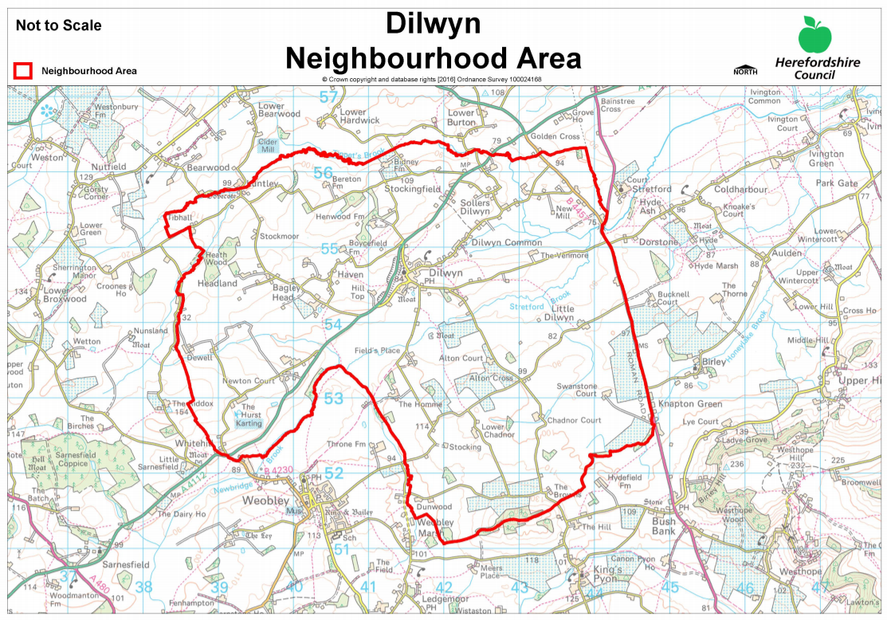

Local Planning Context
- The Herefordshire Local Plan Core Strategy Policy H1 states that all new open market housing proposals on sites of more than 10 dwellings, or which have a maximum combined gross floor space of more than 1000m2, will be expected to contribute towards affordable housing provision. As Dilwyn is within the Hereford Northern and Southern Hinterlands Housing Value Area a target of 35% affordable housing provision on site has been set based on the evidence of need and viability in the housing market.

- Furthermore, HLPCS 2015 identifies Dilwyn as one of the settlements within the Leominster Housing Market Area which will be “the main focus of proportionate housing development”. This proportional development is expanded in Policy RA1 which shows that the Leominster Market Area aims to contribute 730 houses between 2011 and 2031, as part of a total of 5300 houses in the rural areas of Herefordshire. The proportional development of the Leominster HMA is therefore shown to be a 14% increase in rural housing growth in the specifified settlements. This indicative housing growth target will be used as a basis for the production of Neighbourhood Development Plans but will also factor local evidence and environmental factors into final targets.

Chapter 3: Approach

Research Questions
- Housing Needs Assessments at neighbourhood plan level can be focused either on quantity of housing needed, type of housing need, or both. In most cases, there is a need to focus on quantity where the housing target for the settlement being assessed is unclear, for example where the local authority has not set a specific target for the settlement, or where there is no local plan in place.

- In the case of Dilwyn Parish, the local authority has allocated through one major site and a range of smaller development opportunities, 42 dwellings in the parish of Dilwyn. The Parish Council are however interested in increasing this number to address the housing needs of the community and generate resources for new infrastructure.

- The Parish Council believes there is a danger that the community is becoming unbalanced on account of the high house prices and the preponderance of larger dwellings. There is a perception that the proportion of older people has increased, whereas younger people, particularly newly formed households, cannot access properties because there is little AMH and AH is in very short supply.

- As a result, demand for essential services such as the village pub (the Crown Inn) and primary school, are falling, reducing the overall vitality and viability of the village of Dilwyn. Following discussions with the Parish Council, the following research questions have been agreed,

- Given the needs of the resident community in the parish, what quantity of housing is appropriate over the plan period?
- In order to ensure a demographic balance is maintained in the parish, what tenure of housing should policy seek to provide?
- What type and size of housing is suitable?
- How should the parish respond to the housing needs of older people?

Quantity
- To respond to the first of these questions, it is necessary to arrive at an estimate for the required housing growth relying on a number of reliable sources; these are,
- The HLP and HLHMA;
- A proportional share drawn from OAN;
- DCLG Household projections;
- Net dwelling completion rates 2011-2016.

Study Objectives
- The objectives of this report can be summarised as:
- Collation of a range of data with relevance to housing need in Dilwyn Parish relative to the County of Herefordshire;
- Analysis of that data to respond to the research questions that have been established in consultation with the parish;
- Setting out recommendations based on our data analysis that can be used to inform the Neighbourhood Plan’s housing policies;
- The remainder of this report is structured around the objectives set out above:
- Chapter 3 sets out the data gathered from all sources; and
- Chapter 4 sets out our conclusions and recommendations based on our data analysis that can be used to inform the Neighbourhood Plan’s housing policies.

Chapter 4: Relevant Data

Planning Context
- The PPG states that neighbourhood planners can refer to existing needs assessments prepared by the local planning authority as a starting point. As Dilwyn Parish is located within the County of Hereforshire, we therefore turned to the Hereford Local Housing Market Assessment - Updated 2012 (hereafter HLHMA), and the Local Housing Requirements Studies dated July 2011, March 2012 and September 2014. Together, these studies cover the housing market area and inform emerging housing policies at a local authority level, including affordable housing policy.
- These studies draw on a range of data including population projections, housing market transactions and employment scenarios to derive forecasts at the county level as to housing need in the future. As such, they contain a number of points of relevance when determining the degree to which the housing needs context of Dilwyn Parish itself differs from the authority-wide picture.
- For the purposes of finer-grained analysis across such a large area, the HLHMA divides the county into a number of local sub-markets. The plan area falls into the Leominster Housing Market Area. Figure 5 of the HLHMA, reproduced below as Figure 3, defines the boundaries of the sub-areas.
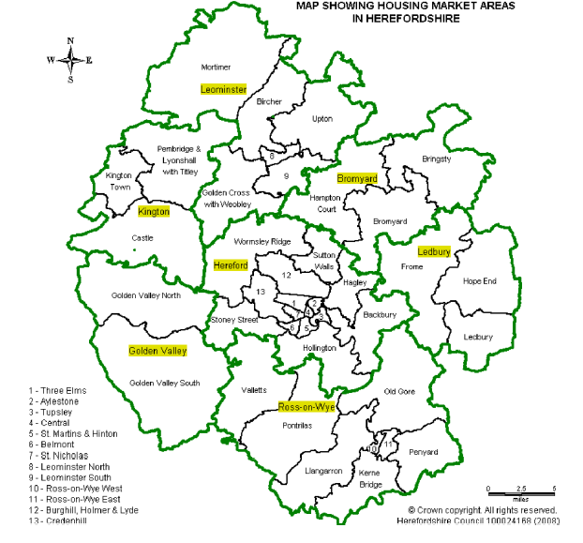
Figure 3. The Housing Market Areas in Herefordshire

Tenure of housing
- The NPPG states that HNAs should investigate household tenure in the current stock and recent supply, and make an assessment, based on a reasonable interpretation of the evidence gathered, whether continuation of these trends would meet future needs or whether, on account of significant misalignments between supply of housing and local need/demand, policies should support a change to the profile of the plan area’s housing stock.

Current Stock
- Our investigation into the currently available homes in Dilwyn looks at the tenure of dwellings, how the current stock of homes breaks down into different types and, finally, the sizes of homes.
- Table 3 shows that the over-whelming majority of properties in Dilwyn Parish are owner-occupied; a significant minority are also privately rented. The number of properties providing social rented accommodation is very low compared with the county and national levels, and the parish, in 2011, had not yet seen any dwellings in shared ownership.
Table 3: Tenure (households) in Dilwyn, 2011
Tenure | Dilwyn | Herefordshire, County of | England
Owned; total | 76.0% | 67.7% | 63.3%
Shared ownership | 0.0% | 1.0% | 0.8%
Social rented; total | 3.3% | 13.9% | 17.7%
Private rented; total | 19.0% | 15.5% | 16.8%

- Table 4 shows the majority of homes are detached properties; these are likely to be larger homes. The proportion of dwellings typically suited to the needs of younger familiies, semi-detached and terraced homes, are low compared with county and national figures, and flatted accommodation is non-existant. While this points to an apparent under-supply of smaller dwellings, typically suited to first time buyers, older people seeking to down-size as well as those on lower incomes, it is important to remember this reflects the rural character of the plan area.

Table 4. Accommodation type (households) in Dilwyn, 2011
Dwelling type |  | Dilwyn | Herefordshire, County of | England
Whole house or bungalow | Detached | 69.5% | 42.4% | 22.4%
 | Semi-detached | 19.0% | 27.4% | 31.2%
 | Terraced | 8.2% | 17.2% | 24.5%
Flat, maisonette or apartment | Purpose-built block of flats or tenement | 0.0% | 8.4% | 16.4%
 | Parts of a converted or shared house | 1.5% | 2.5% | 3.8%
 | In commercial building | 0.3% | 1.2% | 1.0%

Recent supply
- Tables 5 and 6 support the suggestion in table 4 above that the preponderance of the dwellings in the parish are larger homes. Given the amount of new housing has been negligible (our research suggests no new dwellings have been completed between 2001 and 2016, indeed the overall number of dwellings have declined), the changes illustrated in these tables below suggest there has been domestic development activity that has had the effect of changing the overall number of rooms enjoyed by different households. Overall, of the 300 households in the neighbourhood in 2011, 70% live in dwellings of six rooms or more; this compares with roughly 58% for the county as a whole.

Table 5: Rates of change in number of rooms per household in Dilwyn, 2001-2011
 | 2001 | 2001 | 2011 | 2011
Number of Rooms | Dilwyn | Herefordshire, County of | Dilwyn | Herefordshire, County of
1 Room | 3 | 338 | 0 | 300
2 Rooms | 3 | 1355 | 3 | 1563
3 Rooms | 9 | 5248 | 7 | 5703
4 Rooms | 26 | 12013 | 32 | 12125
5 Rooms | 64 | 17320 | 47 | 16469
6 Rooms | 83 | 15382 | 61 | 15150
7 Rooms | 36 | 8978 | 47 | 10233
8 Rooms or more | 92 | 13648 | 103 | 16776
9 Rooms or more | 0

Table 6: Rates of change in number of rooms per household in Dilwyn, 2001-2011
Number of Rooms | Dilwyn | Herefordshire, County of | England
1 Room | -100.0% | -11.2% | -5.2%
2 Rooms | 0.0% | 15.4% | 24.2%
3 Rooms | -22.2% | 8.7% | 20.4%
4 Rooms | 23.1% | 0.9% | 3.5%
5 Rooms | -26.6% | -4.9% | -1.8%
6 Rooms | -26.5% | -1.5% | 2.1%
7 Rooms | 30.6% | 14.0% | 17.9%
8 Rooms or more | 12.0% | 22.9% | 29.8%

- In order to anwer the question of whether this pattern of supply is suited to future need, we have gathered together a number of sources of evidence. Essentially, our task is to identify different market segments for housing in the plan area, as determined by, firstly, their needs and, secondly, what they are able to afford. The following key indicators drawn from Census data are are helpful in achieving the first: age structure and household composition. To understand the second, we must turn to the HLHMA.

- The HLHMA identifies Dilwyn as sitting within the Leominister Housing Market Area (LHMA); more specifically, the rural part of the HMA. The rationale for an HMA is it represents an area with common characteristics as regards the key drivers of housing need and demand. The first and foremost among these is property values, critical to any assessment of suitable tenure, and also relevant to capturing the size and type of dwellings suited to an area when combined with an understanding of local incomes.

- On account of the HLHMA siting the parish of Dilwyn within the LHMA, it is justified, for the purposes of this study, to use the data offered in the HLHMA relating to this HMA as a proxy for the parish, particularly where it refers to rural parts. Mining the HLHMA in this way opens up a rich seam of data relating specifically to affordability, allowing us to form judgements about the kinds of AH that would be suitable and how this may be delivered through policy.

- Our first task, however, is to capture need by drawing on our key indicators, firstly age structure.

Age Structure
- Figure 4 below indicates some striking findings; firstly, the higher proportion of older people, and a corresponding smaller proportion of younger people, in the parish compared with the wider county of Herefordshire. Secondly, the broadly similar numbers of children aged 15 and under, and the high numbers of adults in late middle age, aged 45 and over. One possible explanation for this is that parents may be leaving the decision to have children later in life, a trend common to other places in the UK.

Figure 4: Age Structure comparison between Dilwyn, Herefordshire and England

- While Figure 4 above shows an apparent balance of people of different age groups, table 7 below offers a longitudinal assessment. This reveals that, between 2001 and 2011, there was a marked decline in the proportion of the population in younger adults and a significant increase in the older population, far outstripping national and county data.
Table 7: Rate of change in the age structure of the population of Dilwyn, 2001-2011
Age group | Dilwyn | Herefordshire, County of | England
0-15 | -23.5% | -7.5% | 1.2%
16-24 | 15.4% | 22.4% | 17.2%
25-44 | -30.4% | -7.1% | 1.4%
45-64 | 0.9% | 12.2% | 15.2%
65-84 | 23.6% | 13.7% | 9.1%
85 and over | 63.6% | 34.6% | 23.7%

- Table 8 below reproduces figure 4.61 from the LHRS (2012); this projects the changing age structure across the rural areas of the county to 2031, and suggests that the trends exhibited within Dilwyn of a fall in the numbers of young people, combined with a significant increase in both the proportion of the population who are elderly as well as absolute numbers, is likely to continue through the plan period.

Table 8. Figure 4.61 from the LHRS 2012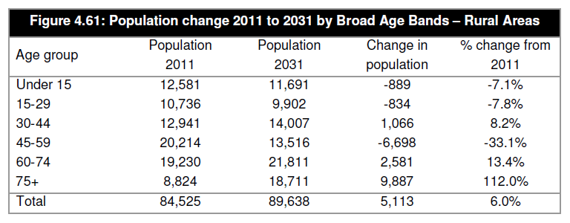

Household composition
- The family orientation of the plan area suggested by the age structure is reinforced by an analysis of household composition; the data shows a high proportion of families compared with county and national figures. The proportion of households with no children is relatively high compared with county and national figures and this agrees with the similarly high proportion of family households in which all occupants are aged over 65. This suggests there are a good number of ‘empty nester’ family households in the parish.

Table 9: Household composition (by household) in Dilwyn, 2011
 |  | Dilwyn | Herefordshire, County of | England
One person household | Total | 25.7% | 28.8% | 30.2%
 | Aged 65 and over | 14.7% | 14.3% | 12.4%
 | Other | 11.0% | 14.5% | 17.9%
One family only | Total | 68.3% | 65.0% | 61.8%
 | All aged 65 and over | 13.0% | 11.3% | 8.1%
 | With no children | 23.0% | 20.0% | 17.6%
 | With dependent children | 26.0% | 24.4% | 26.5%
 | All children Non-Dependent | 6.3% | 9.4% | 9.6%
Other household types | Total | 6.0% | 6.2% | 8.0%

- Taken together age structure, and how it has changed over time, and the composition of households, suggest a need for specialist housing suited to the needs of older people, ensuring there is adequate housing stock for people to ‘downsize’ into, combined with a wide range of accommodation suited to family use.

- It also reinforces the perception of the Parish Council that the balance of the community is shifting progressively towards the upper end of the age range. Therefore, in order to maintain the vitality and viability of the parish, policy should consider encouraging the supply of dwellings suited to younger adults; the LHRS (2014) notes that household formation of younger households (aged 25-34) has been constrained in the county and that a uplift in housing numbers would be approporiate in order to improve affordability.

- This is supported by findings from our interviews with local Estate Agents who firstly identify a shortage of properties suited to young families and also that younger people are the demographic least likely to buy a home.

Table 10: Local Agent Survey data
What number of bedrooms are in demand from renters ? Please rank from 1 to 5, where 1 indicates very high demand and 5 very low demand
No. bedrooms | Cobb Amos | Brightwells | Russell Baldwin & Bright
1 bed | 4 | 2 | 3
2 bed | 2 | 1 | 1
3 bed | 2 | 2 | 2
4 bed | 3 | 3 | 4
5+ beds | 5 | 4 | 5

Table 11: Local Agents Survey data
Local Agent Survey: What age groups are looking for property? Please rank the age bands from 1 to 5, where 1 indicates very high demand and 5 very low demand
Age Group: | Cobb Amos | Brightwells | Russell Baldwin & Bright
18-25 | 4 | 5 | 5
26-34 | 4 | 3 | 4
35-50 | 3 | 1 | 1
51-65 | 2 | 2 | 2
65+ | 1 | 2 | 3

Affordability
- Affordable housing is defined by the NPPF, this document defines it according to a number of categories. It is important to distinguish this from affordable market housing, meaning open-market housing that its within reach of people on moderate incomes (the colloquial meaning of the phrase). In this study we refer to this as AMH so out meaning is clear.

- Table 12 below, which reproduces HLHMA table 1, provides the ‘Affordability Ratio’ for the LHMA; this describes the relationship between the price of properties and household income. While this data is historic it nevertheless it provides a useful starting point in understanding the affordability issues facing the plan area. The figure of 10.2 , meaning that entry level house prices are 10.2 times Lower Quartile Household Incomes, suggests that affordable market housing (AMH) is beyond the reach of many people in the area, with 55% requiring subsidy.

Table 12: HLHMA Table 1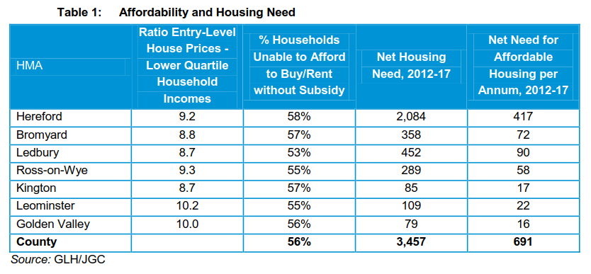
- Working from results from our inteviews with local estate agents, it likely that this picture has deteriorated in the interim given that prices have risen appreciably over the last five years (see table 13 below) and average incomes will not have kept pace with this.

Table 13: Local Agent Survey data
Local Agent Survey: By what percentage have average house prices increased or decreased in the past 5 years?
Agent Name: | Cobb Amos | Brightwells | Russell Baldwin & Bright
Fallen by between 0 and 10%
Stayed the same
Increased between 0 and 10% | X |  | X
Increased between 10 and 20% |  | X
Increased between 20 and 30%
Increased >30%

- As we have seen, only 3.3% of households in Dilwyn are living in some form of social housing. There is therefore a prima facie case for a significantincrease in the ratio of AH to MH in the plan area. This would need to be clarified with reference to housing waiting list data relating to the plan area so as to avoid a scenario in which AH were delivered only to be occupied by people moving into the area on account of local people being ineligible. At this time of developing this study, this data was not available from the local authority.

- In the absence of AH in the parish, need is likely to be addressed in two ways, firsly, displacement to other areas. Indeed, it is not uncommon for AH to be clustered in more urban areas. Secondly, by households living in privately rented sector accommodation (PRS). As noted above, this forms a large part of the housing available in the parish. Since 2012, it has been possible for households in need to claim benefit, known as the Local Housing Allowance (LHA), so as to be able to afford to rent privately. Table 14 below reproduces HLHMA table 27 showing the numbers of LHA claimants at the county level. It is not unreasonable to assume a proportion of these claimants will be in within the plan area.

Table 14: HLHMA table 27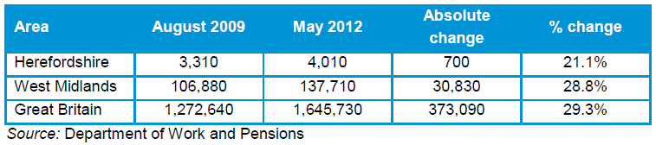

- Tables 15 and 16 below, reproduce HLHMA tables 16 and 17. They show that 66% of households (those earning less than £30,000) and roughly 50% of households (those earning less than £22,800) within LHMA are unable to afford entry-level market housing for sale and rent respectively. Local income levels largely determine levels of need and this, in conjunction with a overall assessment of economic viability of housing development, support Local Plan Core Strategy H1 of 35% AH across developments of a certain size, as noted earlier.

Table 15: Indicative annual income required to buy/rent (2 bedroom)
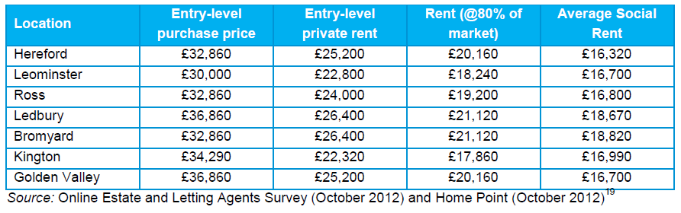

Table 16: Income levels by Housing Market Area
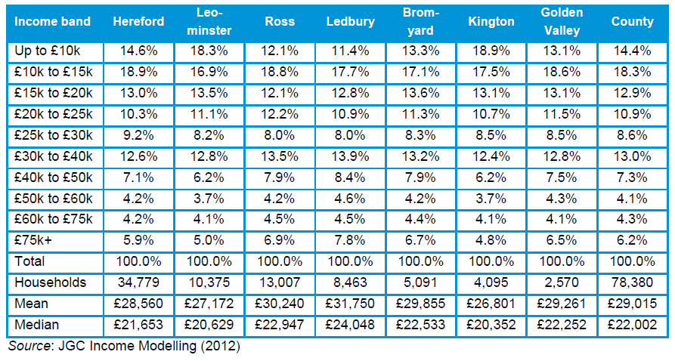

- It is worth noting that the HLHMA states that ‘more recent viability analysis is now suggesting a potential 40% target in the Leominster rural area which is not included in this analysis.’ This indicates that discussions with officers about appropriate AH targets on a site-by-site basis could be helpful.

Intermediate Housing
- The growth in PRS suggests an opportunity for discounted market housing products to address housing need. There may be some households who have a deposit saved up who would buy were they able to afford MH; these households are likely to occupy PRS accommodation.

- Figure x below reproduces HLHMA figure 19 showing the entry level prices for dwelling different sizes across the Hereford HMAs. As we have seen, based on a 3.5 multiple of local incomes, £30,000 is required to buy a two bedroom home. Were this price to drop by 20% to £84,000, the required income drops to £24,000, allowing additional households equivalent to roughly 9% of the population to gain access to the housing market.

- For first time buyers unable to raise a deposit, shared ownership products, as noted in the HLHMA, are likely to appeal.

Figure 5: Entry-level Purchase price by Housing Market Area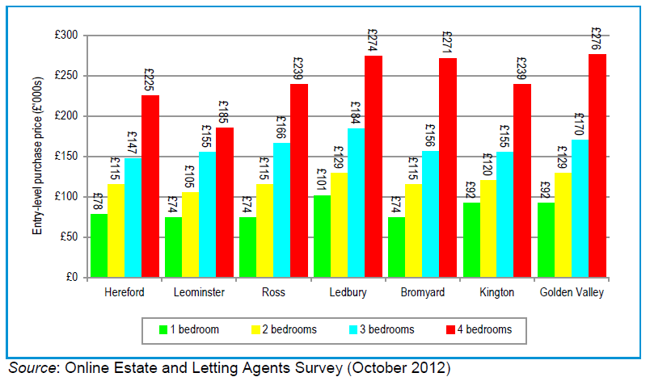

Proportions of affordable housing
- Table 17 below reproduces HLHMA table 2 setting out the estimated proportions of AH across the different types. This has been compiled based on the incomes of households in housing need. This supports current policy at the county level that sets a strategic target of 25% intermediate housing, 25% affordable rented and 50% social rented housing county-wide.

Table 17: Estimated level of housing need (2012 -2017) by intermediate, social/affordable and rented housing
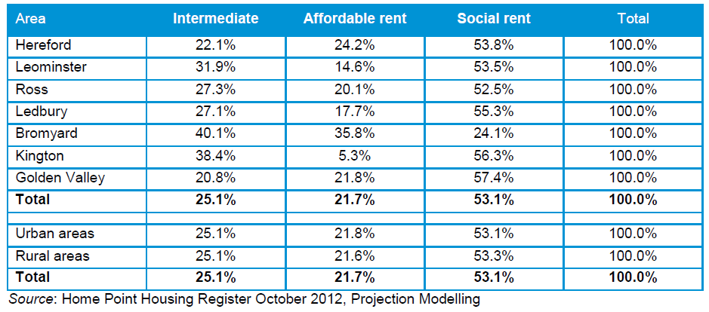

- However, the HLHMA is clear that a ‘one-size-fits-all’ approach is not appropriate and that variations should be made for individual areas if the evidence is there to support it. Table 18 below reproduces HLHMA table 30; this shows that, within the LHMA, data exists to support local plan-makers seeking a higher proportion of intermediate housing and a lower of housing for affordable rent.

Table 18: Estimated level of housing need (five years) by intermediate/social/affordable rented housing (%)
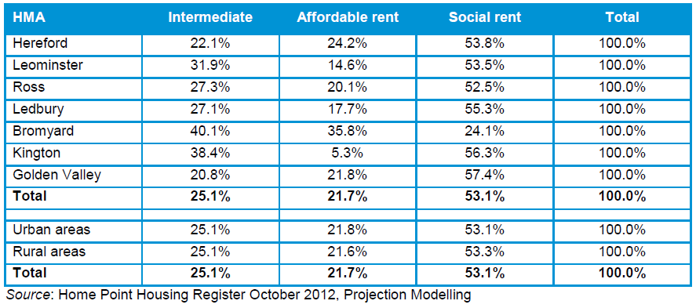

- The recent government White Paper on housing proposes to adjust the definition of AH, so as to bring in ‘affordable home ownership units,’ with a requirement that 10% of all developments over a certain size (so far unspecified). Given the latent demand identified above, we do not think this would be be an inappropriate target in the plan area.

Type and Size

- The type and size of dwelling occupied by a household is driven by similar factors as tenure, although, as the HLHMA points out, the number of indivduals in a given household is of less importance than wealth and age when it comes to chosing a home. This is because, for market housing, most people are driven by lifesyle choice and do not seek to ration their use of space. The only real constraint on space is affordability.

- For this reason, to explore this question, we firstly build on the understanding of household incomes achieved in the previous section. In table 19 below, we reproduce HLHMA figure 38; this shows the Household Incomes in the LHMA. By comparing this with Figure x above, showing entry-level purchase price of properties of different sizes by HMA, it is possible to align sizes of dwellings with people’s ability to pay.

- In order to afford a four bedroom home, priced at around £185,000, using a multiple of 3.5, an income of around £53,000 is required; only around 14% of households earn at or above this figure. While this relates to MH only, given the limited availability of AH, in particular in the plan area, the market will still supply the majority of people’s housing needs in years to come. For this reason, it is important that, in future delivery of market housing, there is a bias in favour of dwellings of a size and type that people can afford.

Table 19: Distribution of Household Incomes in LHMA
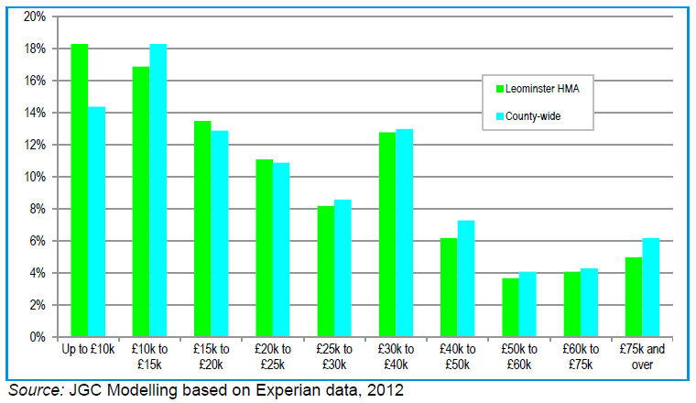

- Data assembled in the HLHMA bears out this assessment, showing that the overwhelming demand, at county level, is for small to medium sized properties. Below we reproduce Figure 27 from the HLHMA which shows the distribution of demand across 1, 2, 3 and 4 bedroom dwellings. The chart also illustrates the overwhelming preference for houses rather than flats.

Figure 6: Size and Type of Market Housing required 2011 to 2031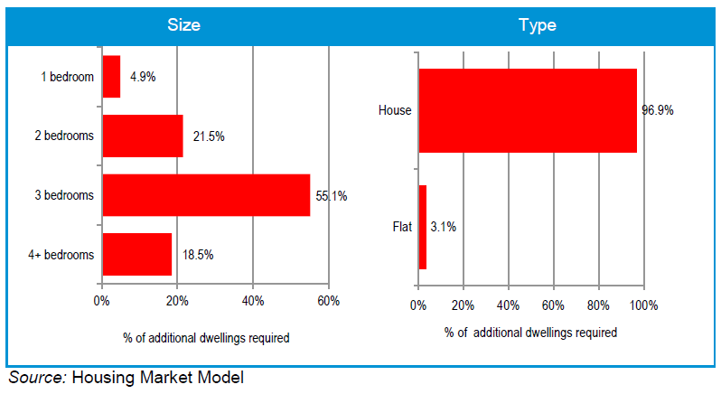
- AH has a similar distribution, although there is a marked increased in the number of 1 bedroom dwellings; again, this will be driven by both age and ability to pay, as well as reflecting demand for social housing stemming from solo households. In addition, the number of those seeking flats is also marked; this will in part be as a result of much of the AH stock being located in urban, rather than rural, settlements from which a substantial proportion of AH demand stems.

Figure 7: Size and Type of Affordable Housing required
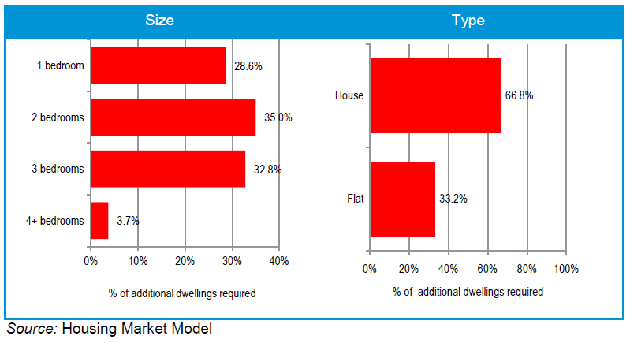

- Figure 59, reproduced as figure 6 above, sets out estimates of the sizes of MH within the LHMA required to meet housing need to 2031. This again indicates a requirement for smaller and medium sized homes, with three bedrooms being in the greatest demand. Notwithstanding this, there is a substantial demand for larger dwellings of four bedrooms and above.

Table 20: Estimated Size and Type of Dwellings Required 2011-2031 – Market Housing (Leominster HMA)
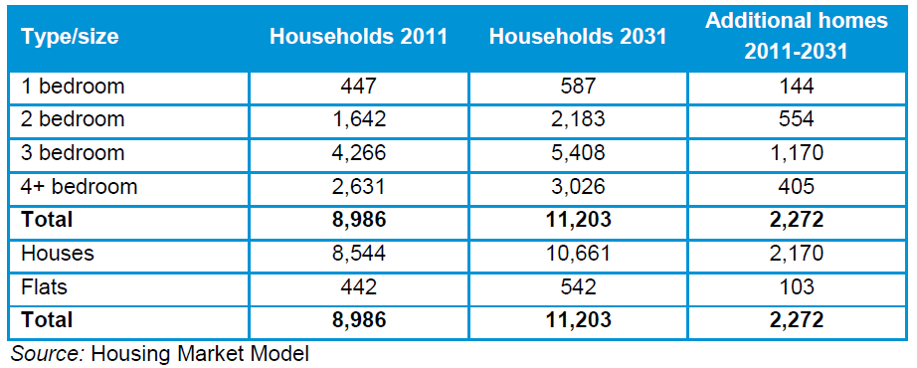

- A similar data set is provided that describes the sizes of AH required over the plan period; this is reproduced below as table 21. This again shows the overwhelming level of demand being centered at the lower end of the size scale; the difference in demand (seen by comparing tables 20 and 21) for larger homes between MH and AH is striking.

Table 21: Estimated Size and Type of Dwellings Required 2011 – 2031 – Affordable Housing (Leominster HMA)
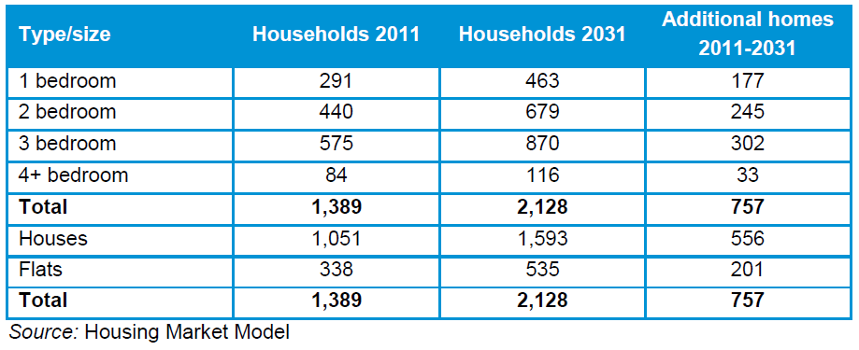

- Table 22 and 23 below reproduce HLHMA tables 61 and 62; these compare levels of demand for different sizes of MH and AH respectively in the urban and rural areas of the LHMA. A key finding is that, for MH, while there is a comparable level of demand for one, two and three bedroom homes in both, there is a substantially lower demand for four bedroom dwellings in the rural parts in the HMA; for urban areas, demand reflects the county trends set out in figure 27. There is also a lower demand for flats in rural areas.

Table 22: Estimated Size and Type of Dwellings Required 2011 to 2031 – Market Housing (Leominster HMA)
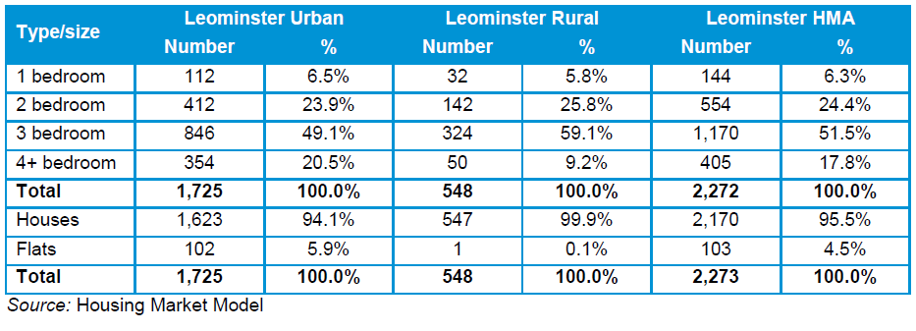
- In the AH sector the data provides a similar finding, with the following contrasts, substantial demand for small dwellings of one bedroom in rural as well as urban locations; very low demand for larger homes of four bedrooms and above in rural areas and the strong demand for flats in urban areas.

Table 23:Estimated Size and Type of Dwellings Required 2011 to 2031 – Affordable Housing (Leominster HMA)
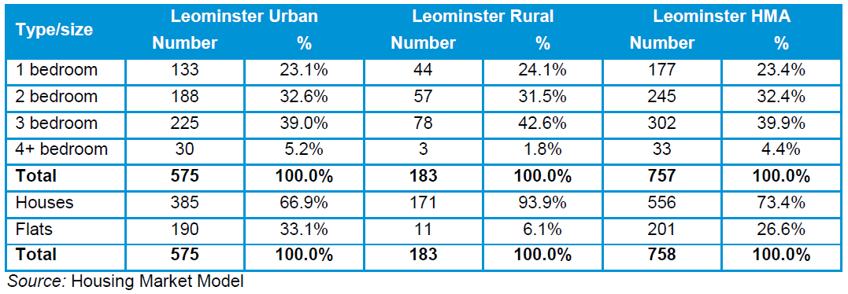

- Turning to age, while the age structure of the plan area was reviewed in the section above looking at tenure, it is worth re-iterating that Dilwyn will be affected by demographic shifts at the macro level, of which the ageing population is perhaps the most dramatic.

- Moreover, it is important for the future sustainability of the settlement that policy supports the provision of AMH for young adults and those bringing up children. The data presented in the HLHMA study recommending a bias towards three bedroom homes may be used in support of this strategic objective, together with a robust approach towards both attracting development and securing appropriate ratios of AH to MH in new housing schemes.

- As noted in the HLHMA, in the event AH delivery through Secion 106 falls short of targets on account of viability issues, other avenues are available and should be explored at the policy writing stage of the Neighbourhood Plan, for example, rural exception sites, community led housing projects and support for self-build.

- In addition, interviews with Local Agents point to a very substantial demand for properties coming from outside the area; the estimates of the ratio of local buyers to thise coming from outside is shown in table x below. Expressed as an average of the ratios, 26% come from inside, and 74% outside. Agents suggest that many of people coming from outside are in the older age bracket, seeking a home in which to retire. This exacerbates the demographic trends set out above and will help maintain the upward movement of house prices. In other areas, this has been addressed through a ‘local needs’ policy; this gives priority access to newly built affordable housing to those with a local connection with the parish.

Table 24: Local Agent Survey data
Local Agents Survey: 8. What percentage of buyers come from within the parish, and what outside? (please indicate percentages for each group, totalling 100%
Agent name: | Cobb Amos | Brightwells | Russell Baldwin & Bright
Fom the local area | 32% | 25% | 20%
Outside local area | 68% | 75% | 80%

The needs of older people
- As we noted earlier, a significant proportion of the population is over 75 and this is likely to grow over the plan period. It is worth re-iterating that, in order to cope with the growing numbers of older people, it is necessary to plan for their needs.

- While, given the comparatively small size of the community in Dilwyn, it is not appropriate to plan specialist housing for the elderly within the Parish, for example, sheltered housing or extra care units, it is appropriate to provide smaller housing units suited to the needs of older people, either living alone, or within a family group.

- It is important to bear in mind that only certain locations are suitable for specialist housing for older people. Many residents value being within walking distance of town centre services and facilities, and away from steep hills; also taking into account that many models of provision are places of employment as well as places of residence, meaning employees need to be able to access the units as sustainably as possible (e.g. by bus or rail). At the same time, centralised dementia care units or enhanced sheltered developments located in rural towns are able to serve a widely dispersed rural population from a single location. For this reason Leominster offeres a more suitable location for these forms of housing.

- Everybody prefers living close to family and friends, but in old age this is particularly important as these connections operate as an informal support network, allowing them to enjoy a better quality of life in their own home for longer. For this reason, a ‘life-time’ homes policy would be appropriate, ensuring a range of housing times, but particularly smaller dwellings of between 4-5 rooms, suitable for downsizing and the mobility needs of older residents.

Quantity
- We have estimated the quantity of housing needed in Dilwyn based on four different sources; these are,
- HLP and HLHMA (updated 2012)
- Herefordshire Council's Core Strategy seeks to deliver 16,500 new homes (net) across Herefordshire over the 2011-31 plan period. On account of a decision to allocate 5300 of this housing growth to rural areas, it is possible, as we have seen, to derive a housing growth projection based on the proportional share taken up by the Leominster HMA of which Dilwyn is part. Within its rural areas, the HMA is expected to contribute 730 houses between 2011 and 2031, as part of this 5300 figure. This amounts to an indicative housing growth target of 14%, which when applied to the 331 dwellings in Dilwyn parish suggests a target of 46 dwellings (rounded) to be provided in the target plan area over the plan period. This target is dependent on supply side factors within each of the Leominster HMA settlements but represents proportionate in each settlement. From data provided by the Local Authority, 2 new dwellings have been ‘committed’ between 2011 and 2016, producing a final projected housing target of 44 dwellings (net).
- Local Housing Requirements Study Update - September 2014 (LHRSU)
- This document offers the most up-to-date assessment of housing need at the county level; it is a demand-side only, or ‘unconstrained’ assessment of need (often identified as Objectively Assessed Need, or OAN), as opposed to a final housing target, which takes into account a number of other factors, including for example the availability of land, viability, infrastructure and environmental constraints and the results of consultation. Nonetheless, the LHRSU presents an appropriate starting point for deriving need at the NDP level, because it is the most up-to-date evidence available.
- The LHRSU identifies a target at the LPA level over the period 2011 - 3 for Herefordshire ranging from 15,400 to 16,200. These figures are drived from a range of annual housing need figures, and include a ‘market signals uplift.’ The lower end of this range aligns with the 2012 SNPP, with adjustments to improve affordability. The higher end is based on evidence from the economic analysis which suggests a higher level might be needed to support growth in employment. For the purposes of this study, we have identified a ‘mid-point’ figure of 15,800 dwellings.
- Dilwyn’s ‘fair share’ of this number is .4% of housing in Herefordshire. This is based on there being, at the time of the last Census in 2011, 331 dwellings in Dilwyn as against a total of 82,549 in the LPA area as a whole. Taking 2011 as the base year to be consistent with the HLP, the plan period is 20 years (2011-31). On this basis, Dilwyn requires 3 new homes per year (rounded), or 63 new homes over the Plan Period. However, of these, 2 where ‘commited’ between 2011 and 2016 and these should be deducted from the total. This produces a revised requirement for 61 dwellings (rounded).

- DCLG Household Projections
- The Department for Communities and Local Government (DCLG) periodically publishes household projections. The NPPG recommends that these household projections should form the starting point for the assessment of housing need.
- The most recent (2014-based) household projections were published in July 2016, and extend to 2039. Although population projections are only available at a local authority level, a calculation of the share for Dilwyn is nevertheless possible for the household projections based on the parish’s household numbers in the 2011 Census.
- At the 2011 Census, Herefordshire had 78,319 households and Dilwyn 300 households, or .383% of the total.
- In the 2014-based household projections, the projection for 2031 is for 91,731 households in Hereford. Assuming it continues to form .383% of the district total, Dilwyn’s new total number of households would be 351 (rounded); therefore 51 new households form in Dilwyn between 2011 and 2031 (or a rate of growth of 2.55 households per year).
- Number of households does not, however, equate precisely to number of dwellings, with the latter slightly higher in most places. Dilwyn is no exception; in the 2011 Census, there were 300 households but 331 dwellings. This gives a ratio of 0.91 households per dwelling (rounded). In the case of Dilwyn, then, a projection of (51/.91) new households translates into a need for 56 dwellings (rounded to the nearest whole number).
- These figures are based on the assumption that 2014-based government projections as to household growth at the Local Authority level are accurate. As the annual mid-year population estimates have now been released for 2015, the 2014-based household projections may need to be ‘rebased’ for accuracy. The mid-2015 population estimates give the actual number of people in Dilwyn at that point, meaning the difference between the estimated and the previously projected number of households, can to be taken into account in future projections.

- The 2014-based household projections were based on the 2014-based Sub-National Population Projections, which estimated that by 2015 there would be 188,198 people in Herefordshire. The mid-2015 Estimates show that based on the latest information there were estimated to be 188,099 people, which is lower than the projections by a very small margin. Given the accuracy of the 2014 projections, we do not propose to make any changes to the housing projections as a result of the rebase exercise. The target within the plan area drawn from DCLG Household projections therefore remains 56 dwellings.

- This projection is an entirely unconstrained, theoretical figure comprising a relative proportion of the overall projected increase, and thus does not take into account political, economic, demographic or any other drivers that might have influenced, or may in future influence, the Local Plan distribution across the District and hence any difference between this figure and a future Local Plan-derived figure.
- Net dwelling completion rates 2011-2016
- It is also worth considering a projection based on the rate of delivery of net new dwellings since the last census (2011), using data gathered and monitored by the LPA. Between 1st April 2011 and the 31st March 2016, 2 net new dwellings have been ‘committed’, though not completed. This equates to an annual rate of delivery of .4 dwellings (2 divided by 5, the number of years elapsed). If this rate of delivery was continued to 2031, this would equate to a projection of approximately 8 dwellings over the plan period of 2011-2031 (.4 x 20). Following the deduction of the 2 units that have been built between 2011 and 2016, this produces a final figure of 6 dwellings.

- Given this would represent a clear shortfall on the required number of dwellings to satisfy the parish’s ‘fair share’ of the Leominster Housing Market Area target, this projection should be set aside; rather, it provides evidence of a supply-side failure to build the dwellings the community needs.

Chapter 5: Market Signals

- The PPG highlights the importance of taking market signals into account when assessing housing need, given they provide an indication of the balance between demand and supply. This is particularly important to consider given the significant and well-documented changes in the housing market over recent years, which were exacerbated by the economic downturn and subsequent issues in obtaining mortgage finance.
- The PPG states: The housing need number suggested by household projections (the starting point) should be adjusted to reflect appropriate market signals, as well as other market indicators of the balance between the demand for and supply of dwellings. Prices rising faster than the national/local average may well indicate particular market undersupply relative to demand.
- These market signals relate to trends discernable within the housing market, and broader economic trends that have an impact on the housing market.
- The PPG goes on to assert that where there is evidence of an imbalance in supply and demand, an uplift in planned housing numbers – compared to those derived solely from household projections – is required in order to increase the supply of housing to meet demand and tackle affordability issues:
- This includes comparison with longer term trends (both in absolute levels and rates of change) in the housing market area; similar demographic and economic areas; and nationally. A worsening trend in any of these indicators will require upward adjustment to planned housing numbers compared to ones based solely on household projections.
- In areas where an upward adjustment is required, plan makers should set this adjustment at a level that is reasonable. The more significant the affordability constraints (as reflected in rising prices and rents, and worsening affordability ratio) and the stronger other indicators of high demand (eg the differential between land prices), the larger the improvement in affordability needed and, therefore, the larger the additional supply response should be.
- To establish the condition of the current housing market in Dilwyn parish, a number of quantitative factors were analysed. These included extrapolating data prepared as part of the evidence base for wider areas, as well as applying wider trends to the established population of Dilwyn. These were supplemented by judiciously used qualitative data obtained from local agents to create an overall depiction of Dilwyn’s Housing market at a more nuanced level than available through higher level deliberation. These market signals are therefore used to adjust the housing needs assessment to anticipate discernible trends and respond to projections likely to influence future demand. As a result, information discerned in the previous chapter is also included in the final conclusionsof this section, notably demographic trends, to generate a more holistic overview.

Housing Transactions
- The PPG advises that house prices should be monitored to identify how longer term trends can stimulate future demand and impact the viability of future development. To assess how the housing market in Dilwyn is performing, property transaction data was gathered from the Land Registry.

- Establishing two periods of assessment between 2005-07 and 2015-17 allowed the construction of ‘housing market snapshots’ which can then be compared. This data was collected using the ‘HR4 8’ sub post code area as a proxy for Dilwyn Parish and yielded approximately 300 property transactions.

- This analysis found that detached properties, which compromised approximately two thirds of all sales in both periods, increased in value an average of 8.6% between 2005 and 2017. Furthermore, in the same period semi-detached properties rose by an average of 24.5%, with terraced house prices rising 17.6%.

- While this seems like a large increase, in the same period the average price in Herefordshire saw a 21.3% rise from £179,399 in 2005 to £217,533. Furthermore, detached houses in this same period in Herefordshire grew 25% (from £250,422 to £313,239) compared to the 8.6% shown in Dilwyn in the same period.

- Despite this, although the plan area has seen broadly similar, and sometimes lower, growth compared to Herefordshire, the Local Authority has historically seen greater increases in house prices than neighbouring counties. The LHRSU in states “across Herefordshire, the average (mean) house price (Jan 2013-April 2014) is £214,000 whilst the median is £183,000. These figures are above the corresponding figures for Shropshire where the mean price is £203,106 and median price is £171,000.”

- Furthermore, the data calculated for the ‘HR4 8’ post code for the period between March 2015 and March 2017 showed that the average property sale value was £279,000 (rounded). Although the area does not directly correspond with Dilwynthese two pieces of evidence suggest that property prices in Dilwyn, although not rising as fast, are higher than the surrounding area.

Rate of development
- The HLHMA update found that in the LHMA “it is estimated that 57% of all households in this HMA cannot afford market housing without subsidy compared to 56% across Herefordshire”. The study also found that the LHMA had a backlog of 199 houses required, which when added to the 5 year newly arising need from 2012-2017 constituting a current need for 837 dwellings.

- The Rural Housing Background Paper released in March 2013 states that “54% of Herefordshire’s population live in rural areas outside of Hereford and the market towns in village or smaller settlements (such as Dilwyn Village), farms or other isolated properties”. Despite this, evidence provided by the local authority shows that as of April 2016 there have been no completions since the 2011 census, although there are 2 commitments. Using the planning portal, it was ascertained that there are currently two current planning permissions in the area, compromising of a potential 12 dwellings although 10 of these are still at the outline stage. The Dilwyn SHLAA identified a single site within the study area with the capacity for multiple dwellings although it possesses significant constraints, notably a need for additional infrastructure. As a result, the site was deemed suitable for a potential development capacity of 15 new dwellings, although it is probably not deliverable in the plan period.

Overcrowding
- Another indicator of increased demand in the housing market is the prevelance of overcrowding. However, within Dilwyn Parish there has been a reduction in population from 756 in 2001 to 711 in 2011. In addition, population density has been reduced from 0.32 people per hectrare (already over half of the Herefordshire average of 0.8) to 0.30. There is also further evidence of less intensive use of rooms, with only four dwellings in the Parish with over one person per room, down from 16 in 2001.

- In both the 2001 and 2011 Censuses the overwhelming majority of households in the parish, 74% and 82% respectively, live at densities of less that 0.5 persons per room. In addition, there are only four examples of concealed families within the parish, a rate of less than 2% which, although high, may be inaccurate, given the small size of the sample.

Employment trends
- Local employment trends can greatly influence housing needs as employment opportunities can stimulate demand. On the other hand, a relative lack of growth can negatively affect house prices as dwellings located far from employment opportunities may be less attractive to those in full time work. In Dilwyn, residents already travel comparatively speaking, a long distance to work, with an average of 20.4 km, above the Herefordshire average of 16.7km. Indeed, only 75 people work within 10km of their home, although 92 residents do mainly work from home.
Table 25: Distance travelled to work by residents, 2011
Location of Work | Dilwyn | Herefordshire | England
Less than 10km | 23.1% | 45.6% | 52.3%
10km to less than 30km | 32.3% | 19.7% | 21.0%
30km and over | 7.4% | 8.9% | 8.0%
Work mainly at or from home | 28.3% | 16.8% | 10.3%
Other | 8.9% | 9.1% | 8.5%
Average distance travelled | 20.4km | 16.7km | 14.9km

- Although the HLP does not promote, allocate or safeguard any land for employment in Dilwyn, Appendix 10 of the Rural Settlement hierarchy paper of 2010 recognises that Dilwyn is in need of additional employment land. Within the commuting range shown earlier, there are some potential growth opportunities that lie outside the plan area. These include the Leominster Enterpise Park, a 15ha site of ‘best quality’ identified in the Employment Land Survey for B1, B2 and B8 usage. This site is deemed deliverable in the first phase of the Core Strategy, with a further 5-10 ha identified for future expansion. The Moreton Business Park in Moreton-on-Lugg is another identified employment site of 60ha between Hereford and Leominster and approximately 10km from Dilwyn Village. Although there are rural employment sites identified within the Core Strategy, none of these are within Dilwyn.
- However, although there are some examples of economic growth in the vicinity, in 2011 34.9% of the plan area were classified as economically inactive, compared to a Herefordshire average of 28.7%, with 12 people declared as unemployed. Another indicator of a reduction in demand for employment within Dilwynis theaging population, as discussed earlier in this document.
- Furthermore, 25.7% of households in the parish are single person, with 58% of these (14.7% of the total) in the 65 or over bracket. As a result, almost a sixth of households in the target area are one person households, with a further 13% of total households comprised of families where all occupants are aged 65 or over. The Housing Older People Study in 2012 states that 20% of the older population in the LHMA are income deprived, one of the highest proportions in Herefordshire. This ageing demographic, which exhibits relatively low income levels combined with low levels of unemployment, may threaten the viability of local businesses.

Chapter 6: Conclusions

Table 26: Market Signals summary
Factor | Source(s) (detailed in Chapter 4) | Possible impact on future housing need | Rationale for judgement
Demographic change | Census, LHRSU (2012) | ↑ | Changes in age structure over the plan period is likely to see a significant growth in the proportion and numbers of people over the age of 75. The area currently has a relatively large number of older people occupying a disproportionately high amount of habitable rooms and therefore some filtering or specialist housing may produce a more effective distribution of the existing housing stock. As a result, an assessment of one up arrow has been made as there is deemed to be an need for an increase in provision of housing suited to ‘downsizing.’
Employment trends | Core Strategy 2015, Rural Settlements Hierarchy Paper 2010. | ↓↓ | Although there are examples of employment growth within the typical commuting distance of the residents of Dilwyn parish, these are unlikely to stimulate additional need for housing in the area due to their vicinity to Leominster and Hereford which are much more densely populated settlements.  One potential impact on the economic viability of the local area, however, is the growing inactivity of the residents caused by an ageing population. As a result, an assessment of two down arrows has been made due to the lack of projected employment growth in the Neighbourhood Plan Area compared with the wider county.
Housing Transactions | Local Housing Market Assessment 2012 update, Local Housing Requirements Study Update, DCLG Live Tables, Rural housing Background Paper March 2013, Local Agent survey | ↑ | The housing market in Dilwyn has been shown to be relatively strong, growing in the last ten years and with higher property prices than neighbouring areas.  The housing stock of the area, typified by detached and semi-detached dwellings and a lack of smaller 2/3 bedroom houses or flats is also joined by a low projected development rate. As a result of this inelasticity in supply any increase in demand will manifest itself as an increase in property prices. Furthermore, there are currently very few opportunities for rent in Dilwyn. As a result, high house prices are likely to increase the need for more affordable or subsidised forms of housing.  Overall, an assessment of one up arrow has been made due to the presence of relatively higher and increasing house prices. This assessment was not higher because these house prices are deemed to be inflated by a significant lack of supply in the Neighbourhood Plan Area.
Overcrowding | Census | ↓↓ | There is relatively little evidence of the overcrowding which typifies inadequate supply. Indeed within the study area, typified by large and non-intensively used housing stock, there is capacity for future need to be accommodated.
Rate of development | Census, Rural Housing Background Paper March 2013, Planning portal data, LA response, Land Registry data. | ↑↑↑ | There have been no completions in the last 6 years, with very few outstanding permissions despite relatively high house prices. An assessment of three up arrows has therefore been deemed appropriate due to this low level of provision, especially in a context of anticipated increasing need across the Leominster HMA. As a result, overall housing need, a combination of past, present and future demand, is likely to be exacerbated by an unresponsive housing market.

Table 27: Housing characteristics Summary
Factor | Source(s) (see Chapter 4) | Possible impact on housing needed | Conclusion
Affordable Housing | Census, HLHMA | Assertive approach to securing high levels of AH  Development of intermediate housing as a type of AH | There is a very small quantity of social housing, which means private rented accommodation shoulders the bulk of the AH burden.  The result of viability analysis shows different viability levels between urban and rural areas within the LHMA; this should encourage an assertive attitude on the part of the parish council in seeking AH as part of development projects, as well as other initiatives, such as AH exception sites  Given the development of intermediate housing as a type of AH, for example the entry of discounted market housing for rent and purchase into the lexicon of ‘affordable housing,’ these types should form a substantial part of AH provision.  Within rural areas of the LHMA, evidence supports provision of AH in the following ratios: intermediate housing, 32%, affordable rent 15% and social rent 53%.
Demand/need for smaller dwellings | Census, Local Agents Survey, HLHMA. | Smaller homes needed to facilitate down-sizing  1, 2 and 3 bed homes should be priority for families and first-time buyers. | There is a preponderance of large homes, creating a 'top heavy' profile in the current housing stock; this, and other evidence, suggests an under-supply of smaller homes. Local agents report both high demand for three bed properties and an under-supply of these sizes of homes.  Within rural parts of the LHMA there is strong demand for small homes, but not flats, suggesting a mixed typology of dwellings would be approporate in future development, offering one, two and three bedroom homes with a very small number of larger family dwellings.
Demographic Change | Census, LHRSU (2012) | Very substantial increase in older residents is forecast over the plan period | While the population of the parish is too small to warrant specialist housing for the elderly, policy that supports general housing suited to their needs is appropriate
Dwelling size | Census, HLHMA. | No further development of larger homes to rebalance stock in favour of smaller dwellings to address mis-alignment issues. | The preponderance of larger homes in the area suggests that policy should not seek the delivery of homes of four or more bedrooms.  This is supported by demand data which suggests that, while there is strong demand for homes of all scales at county level, within the rural parts of the LHMA there is substantially less demand for AH of four bedrooms and above.  As set out above, there is negligable demand for flats in the plan area; development should therefore offer 1,2 and 3 bed houses.
Family-sized housing | HLHMA, Local Agent Survey | New housing should concentrate on housing families can both use and afford. | Given only a minority of people can afford family housing in the plan area, it is imperative future development supplies housing suited to a family’s needs, but of a type and size they can afford.  The ratio of dwellings sold to people outside the area supports the idea of a local needs policy applied to new AH.
Housing for independent living for older people | Census, HLHMA | Life-time homes policies should be considered | The age structure, how it has changed over time, and the composition of households, suggest a need for ‘life-time homes’ style development. This will help ensure there is adequate housing stock for people to downsize into, combined with a wide range of accommodation suited to family use.
Specialist housing | Census | Not suitable location for provision of specialist housing | The population size within the plan area does not support the delivery of specialist housing beyond general housing suited to the needs of the older resident. Within the LHMA, Leominster is the most appropriate location for such housing.
Tenure of housing |  | More households likely to fall into need as a result of increasing house prices  PRS should be encouraged given the role it plays in providing AH and allowing people to remain in the area. | House price increases are likely to have outstripped real wage increases, placing greater pressure on people's ability to afford housing.  The widespread take-up of PRS suggests a latent demand for discounted market housing and shared ownership products. New development could include Build-to-Rent (BTR); this is housing delivered by specialist developers designed to be occupied specifically by renters, and covenanted for that purpose for a number of years. This would be a means of maintaining the flow of PRS housing, a portion of which may be ‘discounted market rent’. Following the Housing White Paper, this is likely to be included in the definition of AH with the review of the NPPF, expected later this year.  Discounted market housing is suited to first-time buyers who can raise a deposit.

Recommendations for next steps

- This neighbourhood plan housing needs advice has aimed to provide Dilwyn Parish with evidence on housing trends from a range of sources. We recommend that the parish should, as a next step, discuss the contents and conclusions with Herefordshire Council with a view to agreeing and formulating draft housing policies, in particular the appropriate approach to identifying the level of need for new housing in the plan area, bearing the following in mind:

- Neighbourhood Planning Basic Condition E, which is the need for the neighbourhood plan to be in general conformity with the adopted strategic development plan HLP;
- the views of Herefordshire Council – in particular in relation to the housing need figure that should be adopted;
- the views of local residents;
- the views of other relevant local stakeholders, including housing developers; and
- the numerous supply-side considerations, including local environmental constraints, the location and characteristics of suitable land, and any capacity work carried out by the Herefordshire Council, including but not limited to the SHLAA
- the recommendations and findings of this study.

- Recent changes to the planning system, forthcoming changes to the NPPF, as well as the implementation of the Housing and Planning Act, will continue to affect housing policies at a local authority and, by extension, a neighbourhood level.

- This advice note has been provided in good faith by AECOM consultants on the basis of housing data and national guidance current at the time of writing (alongside other relevant and available information).

- Bearing this in mind, we recommend that the steering group should monitor carefully strategies and documents with an impact on housing policy produced by the Council or any other relevant body and review the neighbourhood plan accordingly to ensure that general conformity is maintained.

- At the same time, monitoring ongoing demographic or other trends in the factors summarised in Tables 26 and 27 would be particularly valuable.
AECOM (NYSE: ACM) is a global provider of professional technical and management support services to a broad range of markets, including transportation, facilities, environmental, energy, water and government. With approximately 45,000 employees around the world, AECOM is a leader in all of the key markets that it serves. AECOM provides a blend of global reach, local knowledge, innovation, and collaborative technical excellence in delivering solutions that enhance and sustain the world’s built, natural, and social environments. A Fortune 500 company, AECOM serves Clients in more than 100 countries and has annual revenue in excess of $6 billion.

More information on AECOM and its services can be found at www.aecom.com.
Address: Bridgewater House, Whitworth Street, Manchester M1 6LT
Phone number 0161 907 3500

See Planning Practice Guidance Paragraph: 006 Reference ID: 2a-006-20140306
Such an approach, clearly separating housing need assessment from dwelling capacity assessment, was endorsed by the Government for calculating housing need at local authority level in the ministerial statement and press release ‘Councils must protect our precious green belt land’ (DCLG, 4 October 2014, available at https://www.gov.uk/government/news/councils-must-protect-our-precious-green-belt-land)
The concept of Lifetime Homes was developed in the early 1990s by a group of housing experts. Lifetime Homes are ordinary homes incorporating 16 Design Criteria that can be universally applied to new homes at minimal cost; many Local Authorities have developed policy to address the needs of older resident based on these criteria. Further details can be found at http://www.lifetimehomes.org.uk/.
Fixing our broken housing market, p 100
The Herefordshire Local Plan Core Strategy, 2015, Page 109.
LHRS (2014), 61
NPPF, 50
HLHMA, 108
HLHMA, 108
HLHMA, 22
HLHMA, 21
Fixing the Broken Housing Market, 59
HLHMA, 103
HLHMA, page 16
HLHMA, page 100-101
The OAN includes the baseline demographic need, plus any adjustments made to official forecasts to account for projected rates of household formation post 2021, past suppression of the formation of new households, the effect of past under-supply, employment forecasts, market signals and affordable housing need (as set out in paragraph ID2a-004 of the NPPG). This is sometimes described as ‘policy off’ because it does not take account of final policy responses as a result of taking into account capacity, environmental and infrastructure constraints.
LHRSU (Sept 2014), page 61
See 2014-based DCLG Household Projections live tables at https://www.gov.uk/government/statistical-data-sets/live-tables-on-household-projections
http://planningguidance.communities.gov.uk/blog/guidance/housing-and-economic-development-needs-assessments/methodology-assessing-housing-need/#paragraph_019
http://planningguidance.communities.gov.uk/blog/guidance/housing-and-economic-development-needs-assessments/methodology-assessing-housing-need/#paragraph_020
LHRSU 2014. Section 5.12 Page 43.
HLHMA 2012 Section 8.20 Page 136.
Rural Settlement Hierarchy Background Paper Updated November 2010
A study of the Housing and Support needs of Older People in Herefordshire. Final Report January 2012. Page 30.
The concept of Lifetime Homes was developed in the early 1990s by a group of housing experts. Lifetime Homes are ordinary homes incorporating 16 Design Criteria that can be universally applied to new homes at minimal cost; many Local Authorities have developed policy to address the needs of older resident based on these criteria. Further details can be found at http://www.lifetimehomes.org.uk/.
Fixing our broken housing market, p 100

