a

DILWYN PARISH COUNCIL

Clerk – Gwilym Rippon
Email: DilwynParishCouncil@mybtinternet.com

Members of Dilwyn Parish Council are summoned to attend
an Ordinary Meeting of the Parish Council on

Thursday 6th February 2018 at 7.30pm at Parish School, Dilwyn

AGENDA
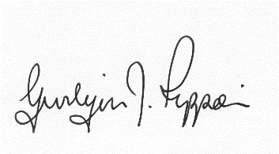
Gwilym J. Rippon, PSLCC, Cert He Ceg
Clerk to the Parish Council

Agenda No. | Agenda item
 | To receive apologies.
 | To receive declarations of interest.
 | To receive any written requests for dispensations (if any).
  - To receive the police report (if any).
  - To receive the ward councillor’s report (if present).
  - To receive questions from members of the public
 | To approve the minutes of the last Parish Council meeting held on Tuesday 4th January 2018
 | Information arising from the minutes.
 | Correspondence received
Financial matters.
- To receive the bank balances for the end of January 2018
- To discuss and decide invoices for payment as per schedule
Highways matters.
- Balfour Beatty.
Planning
There is no planning to date
 | Update on the Neighbourhood Plan
 | Items for the next agenda.
51. Update from the Crown Public House and associated finance.
3. Update on the proposed use of the redundant building on the Crown Inn property.
 | Date and time of next meeting.

