DILWYN NEIGHBOURHOOD PLAN

Members of Neighbourhood Plan Group are invited to attend
a Meeting of the Parish Neighbourhood Plan on

Thursday 20th February 2018 at 7.30pm at St Mary’s School, Dilwyn

AGENDA
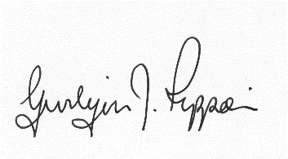
Gwilym J. Rippon, PSLCC, Cert He Ceg
Temp Sec

Agenda No. | Agenda item
 | To receive apologies.
 | To receive declarations of interest.
 | New secretary
 | Site Assessment with Bill Bloxham
 | Comments from Octobers public consultation
 | Instruct Data Orchard to start the draft policy.
 | Meeting with Dr Richard Dales with a member of NDP
 | Next Grant
 | Items for the next agenda
 | Date of the next meeting

