DILWYN NEIGHBOURHOOD PLAN

Members of Neighbourhood Plan Group are invited to attend
a Meeting of the Parish Neighbourhood Plan on

Tuesday 12th June 2018 at 7.15pm at St Mary’s School, Dilwyn

AGENDA
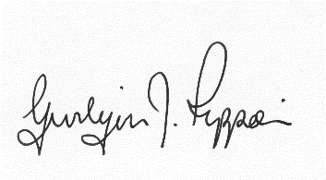
Gwilym J. Rippon, PSLCC, Cert He Ceg
Temp Sec

Agenda No.
Attendance and to receive apologies.

To receive declarations of interest.

Minutes of the meeting 17th April 2018

Draft NDP Version 4 (Bill Bloxsome)
What still needs to be done?
Can the site survey be placed on the Website.
Open Green Spaces

Consultation
1, Draft will be on the agenda of next PC meeting in July
Next Grant application J. Gerrish update.

Actions before the next meeting.

Date of the next meeting

