DILWYN NEIGHBOURHOOD PLAN

Members of Neighbourhood Plan Group are invited to attend
a Meeting of the Parish Neighbourhood Plan on

Tuesday 20th March 2018 at 7.15pm at St Mary’s School, Dilwyn

AGENDA
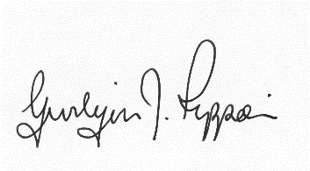
Gwilym J. Rippon, PSLCC, Cert He Ceg
Temp Sec

Agenda No.
Attendance and to receive apologies.

To receive declarations of interest.

Minutes of the meeting 27th February 2018

Questionnaire comments analysis. SR

Site analysis/report (Bill Bloxham)
1. Housing Site Assessment
(a) Confirmation of Sites
(b) Confirmation of Assessment Criteria
(c) Update on Assessment with initial findings
(d) Confirmation of Approach

To consider possible number of dwellings required

Open Green Spaces (PK&AB)

Areas to include in our draft NDP plan.
((Discussion on other matters to be included in the NDP)
Next Grant application J. Gerrish

Instruct Data Orchard to start the draft policy if appropriate.

Actions before next meeting.

Date of the next meeting

