DILWYN PARISH COUNCIL

Clerk – Gwilym Rippon
Email: DilwynParishCouncil@mybtinternet.com

Members of Dilwyn Parish Council are summoned to attend
an Ordinary Meeting of the Parish Council on

Tuesday 5th June 2018 at 7.30pm at St Mary’s Parish School, Dilwyn

AGENDA
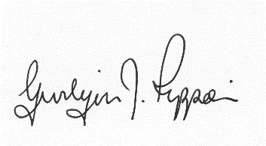
Gwilym J. Rippon, FSLCC, Cert He Ceg
Clerk to the Parish Council
PTO
Agenda No. | Agenda item
 | To receive apologies.
 | To receive declarations of interest.
 | To receive any written requests for dispensations (if any).
  - To receive the police report (if any).
  - To receive the ward councillor’s report (if present).
  - To receive questions from members of the public
 | To approve the minutes of the last Parish Council meeting held on Tuesday 1st May 2018
 | Information arising from the minutes.
Correspondence received
To review the new standing orders
Financial matters.
- To receive the bank balances for the end of May 2018
- To receive the internal auditors report
- Request from the Dilwynner for a grant of £500.00p
- To discuss and decide invoices for payment as per schedule
Highways matters.
- Balfour Beatty.
- Work for lengthsman
Planning
- 181707
Application for an extension to an existing stock building to cover a
manure storage area and open cattle loading area at – Tibhall Broxwood, Leominster, Herefordshire HR6 9JR
- 181704
Application for a bay extension to an existing agricultural storage
building and an infill cover to an existing open silage pit at – Tibhall Broxwood, Leominster, Herefordshire HR6 9JR
 | To discuss the village, clean up
 | Update on Litterbins and grit bins
 | Update on the Neighbourhood Plan
 | To discuss the premises licence
 | Items for the next agenda.
The Crown
- Update from the Crown Public House
- To ratify decisions made between meetings re new managers
 | Date and time of next meeting.
Items for inclusion on the next agenda should be submitted to the clerk eight days prior to the meeting.

Email: DilwynParishCouncil@mybtinternet.com

