DILWYN PARISH COUNCIL

Clerk – Gwilym Rippon
Email: DilwynParishCouncil@mybtinternet.com

Members of Dilwyn Parish Council are summoned to attend
an Ordinary Meeting of the Parish Council on

Tuesday 4th September 2018 at 7.30pm at St Mary’s School, Dilwyn

AGENDA
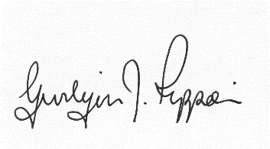
Gwilym J. Rippon, FSLCC, Cert He Ceg
Clerk to the Parish Council
Agenda No. | Agenda item
 | To receive apologies.
 | To receive declarations of interest.
 | To receive any written requests for dispensations (if any).
  - To receive the police report (if any).
  - To receive the ward councillor’s report (if present).
  - To receive questions from members of the public
 | To approve the minutes of the last Parish Council meeting held on Tuesday 3rd July 2018
 | Information arising from the minutes.
 | Correspondence received
Financial matters.
- To receive the bank balances for the end of August 2018
- To discuss and decide invoices for payment as per schedule
Highways matters.
- Balfour Beatty.
- To discuss the Highways Consultation
- Work for Lengthsman
Planning
182056
Application for proposed agricultural building to be used as a manure store at Alton Court Farm, Dilwyn, Hereford, Herefordshire HR4 8HD
 | To discuss the arrangements for Carols on the Green
- p | Update on the Neighbourhood Plan
 | Items for the next agenda.
The Crown
- To discuss the tenancy
 | Date and time of next meeting.
Items for inclusion on the next agenda should be submitted to the clerk eight days prior to the meeting.

Email: DilwynParishCouncil@mybtinternet.com

