DILWYN PARISH COUNCIL

Clerk – Gwilym Rippon
Email: clerk@dilwynparishcouncil.gov.uk
Web Site: http://www.dilwynparishcouncil.gov.uk/

Members of Dilwyn Parish Council are summoned to attend
an Ordinary Meeting of the Parish Council on

Tuesday 2nd April 2019 at 7.30pm at St Mary’s School, Dilwyn

AGENDA
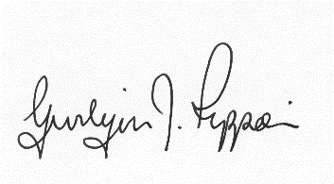
Gwilym J. Rippon, FSLCC, Cert He Ceg
Clerk to the Parish Council
Items for inclusion on the next agenda should be submitted to the clerk eight days prior to the meeting.

Email: clerk@dilwynparishcouncil.gov.uk

Agenda No. | Agenda item
 | To receive apologies.
 | To receive declarations of interest.
 | To receive any written requests for dispensations (if any).
  - To receive the police report (if any).
  - To receive the ward councillor’s report (if present).
  - To receive questions from members of the public
 | To approve the minutes of the last Parish Council meeting held on Tuesday 5th March 2019
 | Information arising from the minutes.
 | Correspondence received
Financial matters.
- To receive the bank balances for the end of March 2019
- To discuss and decide invoices for payment as per schedule
Highways matters.
- Balfour Beatty.
- Work for Lengthsman
Planning
P190792/FH
Application to replace existing front porch with slightly larger porch at Coronation Villa, Headlands, Pembridge, Leominster, Herefordshire HR6 9EJ
 | To discuss ‘Dilwyn Walks’
 | Update on the Neighbourhood Plan
 | Items for the next agenda.
The Crown
Update
Date and time of next meeting.
This will have to be after the normal date due to the elections suggest either 9th , 13th or 16th May

